Reinforcement learning – assignment 2
Tomer Ashkenazy – 318961265
Ohad Sheelo – 318473816
Section 1:
- The Advantage value reflects how much better a specific action is compared to the average value of the state (the baseline). Instead of just measuring if the reward is high, it measures if the action yielded a result better or worse than expected for that state. Subtracting the baseline focuses the gradient on the relative change instead of the absolute value of the return, which reduces the numerical range and the volatility of the updates.
- The fundamental prerequisite for this equation to hold is that the baseline function must not vary with the action. It can be a function of the state (or a constant), but it must be independent of the specific action taken at that time step. proof:
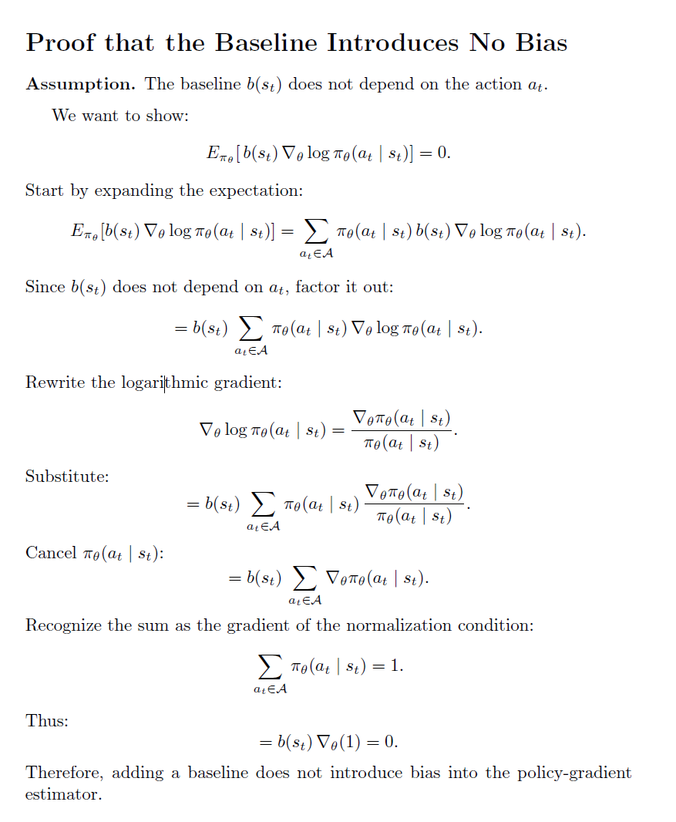

Agent | Learning Rate | Gamma | Solved Episode
REINFORCE + Baseline | 0.01 | 0.99 | 600
Basic REINFORCE | 0.001 | 0.99 | 800
REINFORCE + Baseline | 0.001 | 0.99 | 900
REINFORCE + Baseline | 0.0005 | 0.99 | 1300
Basic REINFORCE | 0.01 | 0.95 | 1400
grid search results (Solved Episode – how many episodes to stop condition):

hyperparameters used for all of the training:
Hyper Parmeter | value
Episodes | 1500 - with a stop condition if achieve an average reward of 475 over last 100 episodes
Activation function | Relu
Num layers (policy NN) | 2
Num layers (value NN) | 2
Hidden layers dimension | 128

Basic REINFORCE training results:
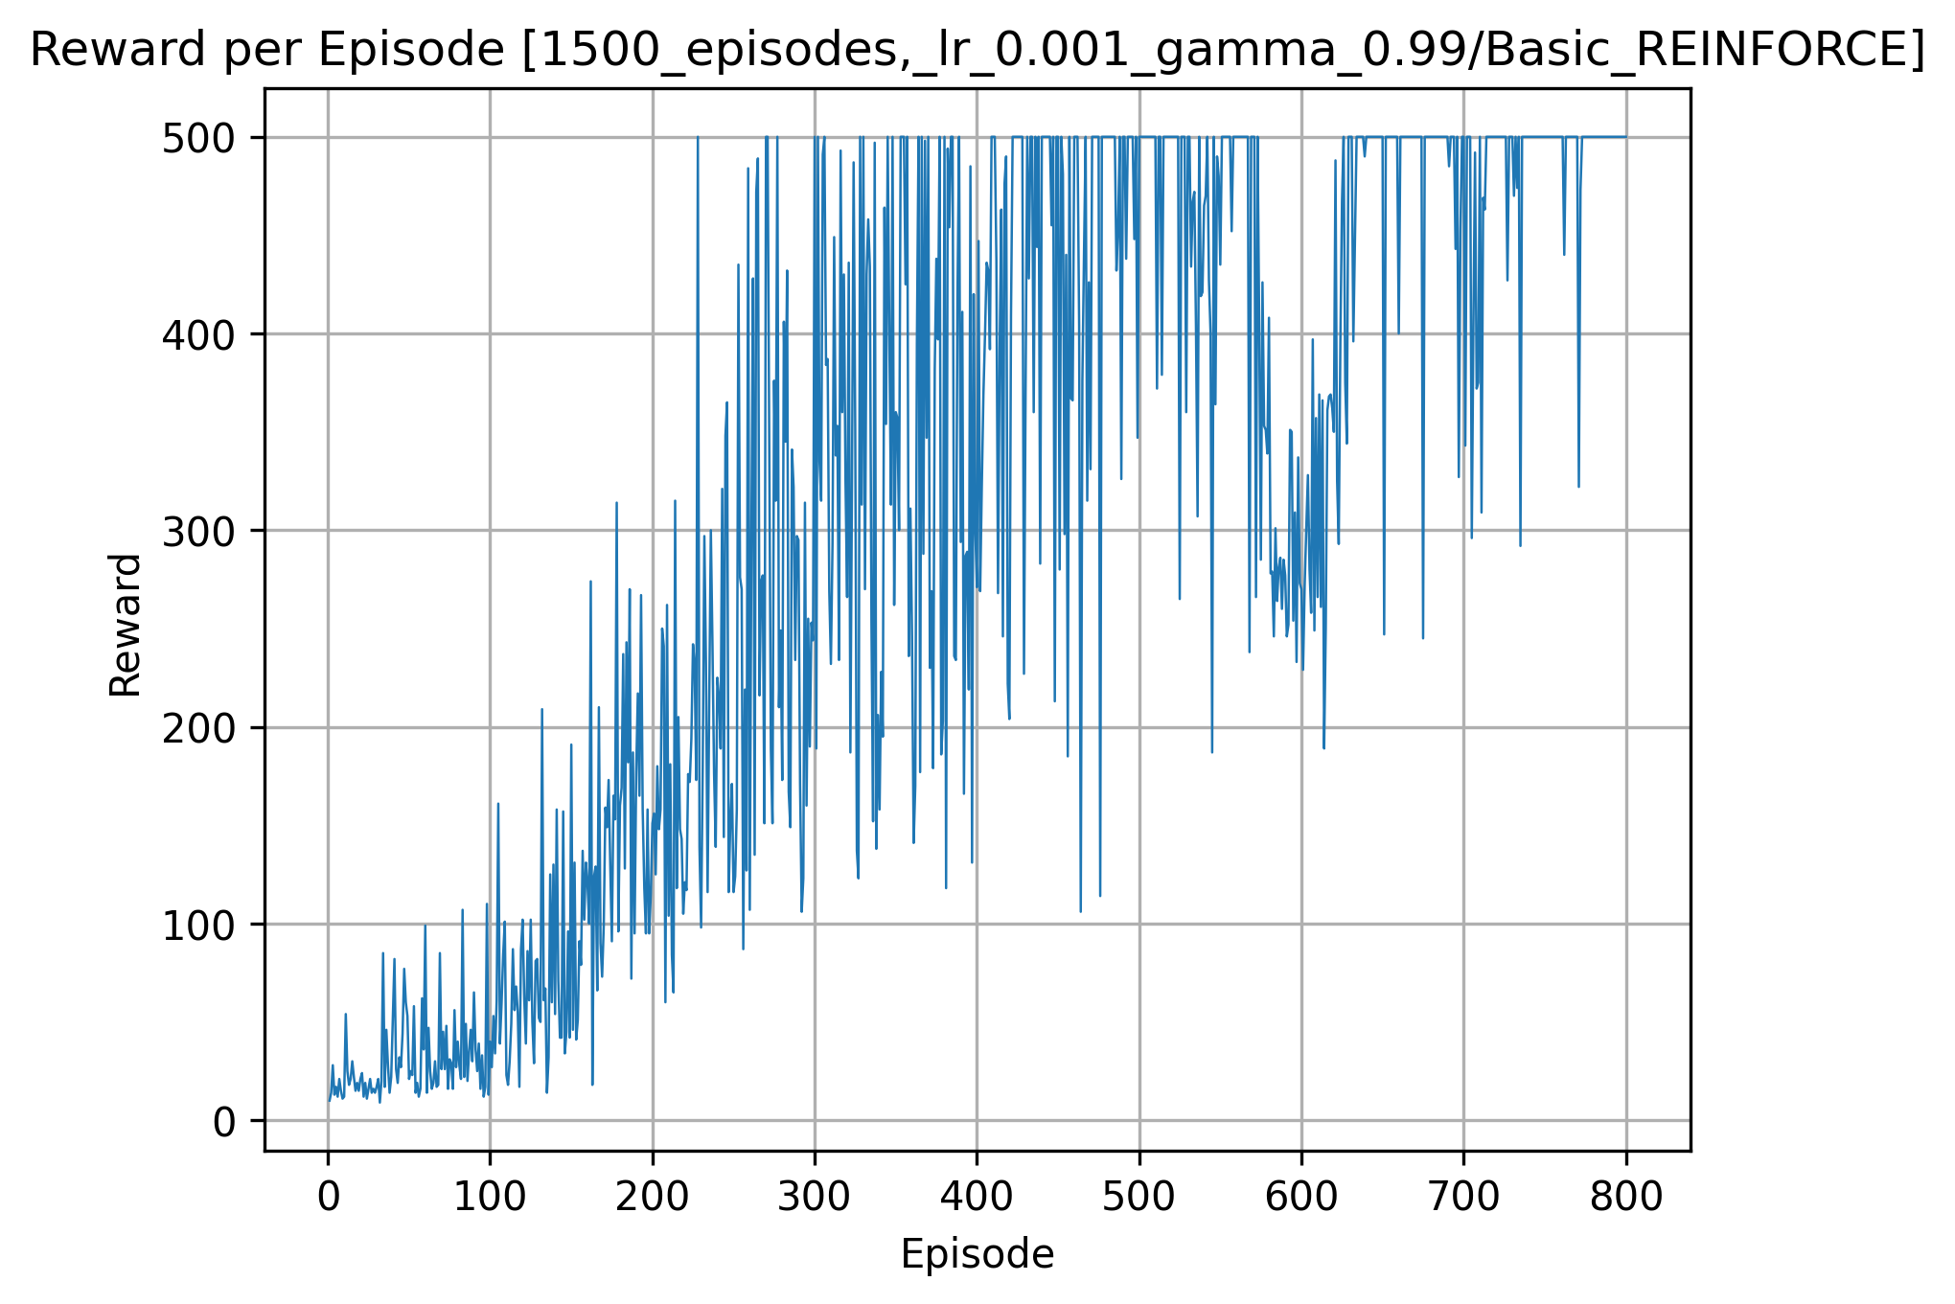

Advantage estimate training results:
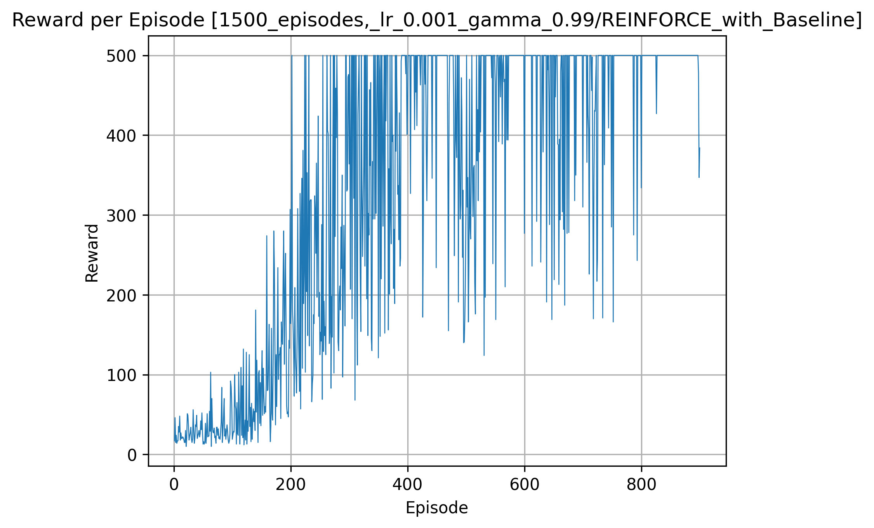
Comparison between the two models:
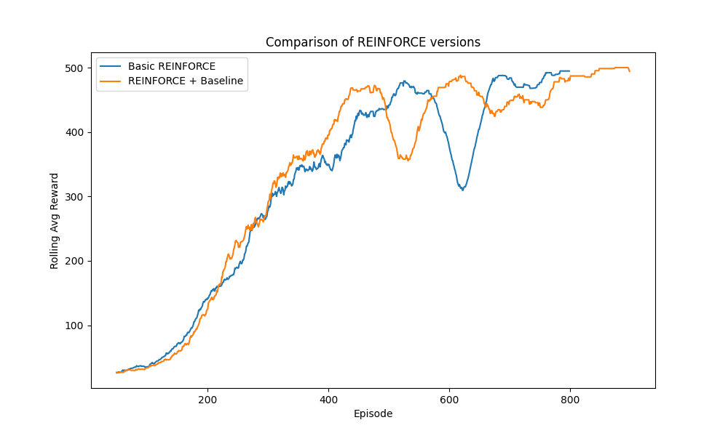
As shown in the third plot, both training methods successfully converge with the desired reward. However, REINFORCE with a baseline reaches high rewards faster and exhibits smoother learning. This behavior can be attributed to variance reduction in the policy-gradient estimator: because the baseline is not varied with action subtracting a baseline does not affect the expected gradient but reduces its variance, leading to more stable updates. The baseline effectively transforms the return into an advantage-like signal, reinforcing actions that perform better than expected and suppressing inferior actions. In contrast, the basic REINFORCE method relies on full Monte Carlo returns, which results in higher variance and larger oscillations during training.
Section 2:
- We prove that the temporal-difference (TD) error of the value function is an unbiased estimator of the advantage function. In particular, conditioned on a state action pair $\left(s_{t} , a_{t}\right)$, the expectation of the TD error equals the true advantage $A^{π}(s_{t},a_{t})$. Consequently, when updating the policy network parameters over time, Monte Carlo sampling of the TD error yields an update direction whose expectation matches that of using the advantage function.
proof:
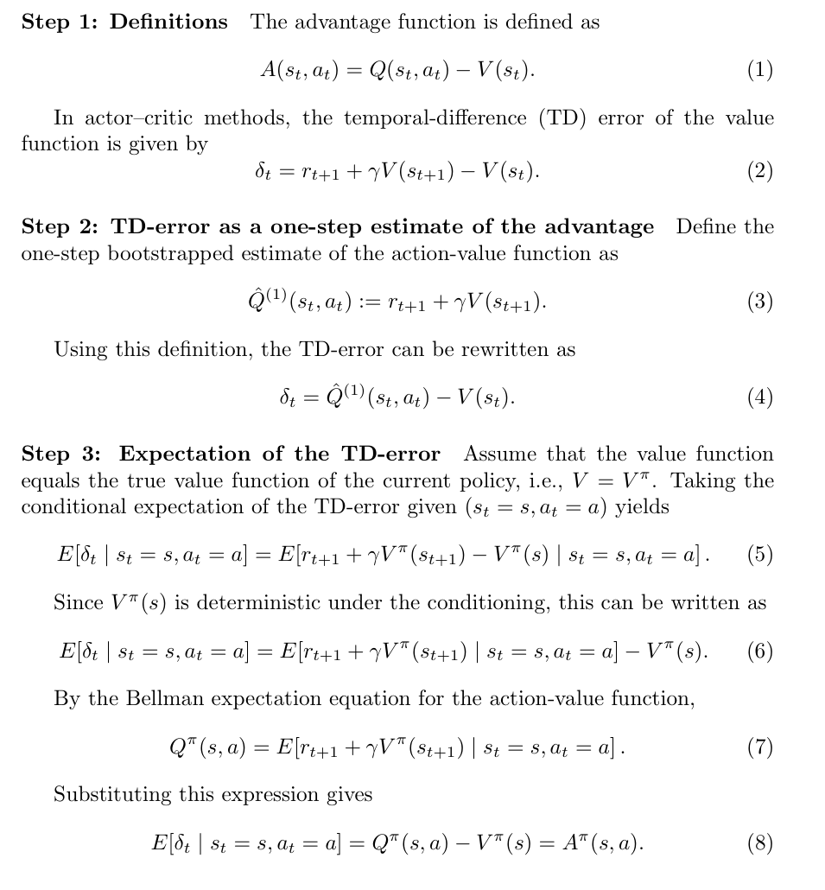
Actor: A function (e.g., a neural network) that represents the policy. For a given state, it outputs action probabilities and determines how the agent acts. Therefore, it is called an Actor.
Critic: The critic is the coach/teacher. It is a value function (e.g NN) and it evaluates the current policy (actor). Using it we can calculate the TD error and tell how good the current state is.

Grid search results - in the Actor-critic models the learning rate of the q function and learning rate b is for the value function. The REINFORCE models use the learning rate.
All of the policy and value network had these
Hyper Parmeter | value
Episodes | 1500 - with a stop condition if achieve an average reward of 475 over last 100 episodes
Activation function | Relu
Num layers (policy NN) | 2
Num layers (value NN) | 2
Hidden layers dimension | 128

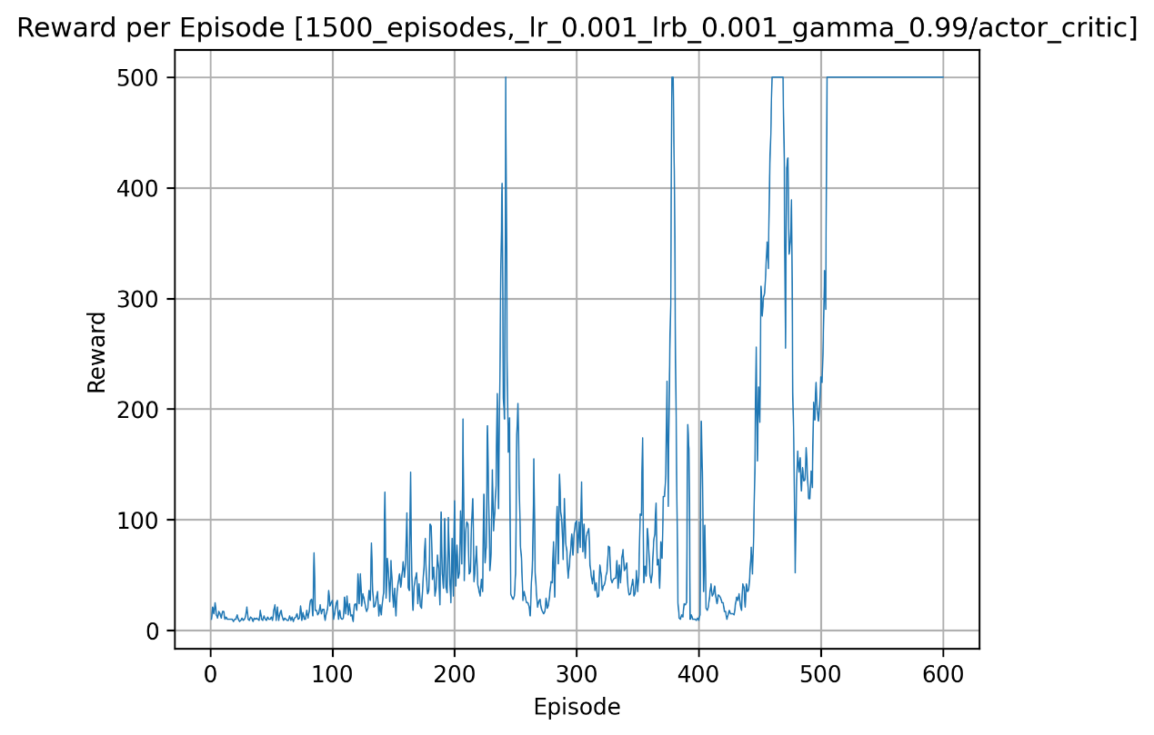
Actor critic training results:

Comparation between all three methods:
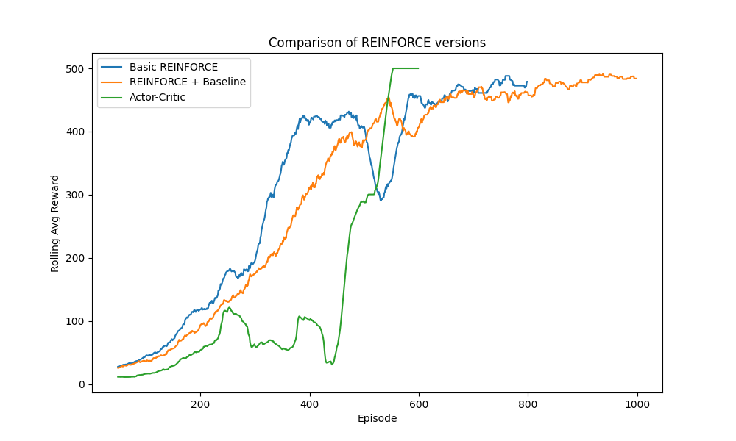
These plots show that all three methods eventually converge to the maximum reward, but their learning behavior differs.
The Actor - Critic method can converge very quickly when appropriately tuned, often reaching high rewards in relatively few episodes. However, it is highly sensitive to hyperparameter selection: many tested configurations failed to reach an average reward of 475. This sensitivity is reflected in the sharp performance drops and spikes observed in the plot and highlights the instability that can arise when the critic provides inaccurate value estimates.
REINFORCE with a baseline demonstrates the most stable and reliable learning behavior. It reaches high rewards in most runs and exhibits the smoothest learning curve. This improvement is due to variance reduction in the policy-gradient estimator, as the baseline effectively transforms returns into an advantage-like signal, producing more consistent updates.
Basic REINFORCE also converges but shows noticeably larger oscillations throughout training because it relies solely on high-variance Monte Carlo returns.

